QuickBite Delivery Analytics- Capstone Project

Business Problem
QuickBite is growing in order volumes, but management is unclear about:
- Which cities generate the highest order volumes and delivered net revenue?
- Which cities have the highest and lowest average order values?
- Which cities experience the longest delivery times and highest delay rates?
- What are the city-wise cancellation and pending order patterns?
- Which cities should be prioritized for operational improvements and market expansion?

Problem Statement
The objective of this project is to analyze QuickBite's city-wise fulfillment and market penetration performance using order, customer, restaurant, revenue, and delivery data. The analysis aims to identify high-performing and underperforming cities based on order volume, delivered net revenue, average order value, delivery time, cancellation rates, and pending orders.
The project seeks to uncover regional performance gaps, highlight potential causes of fulfillment inefficiencies, and provide actionable business recommendations to improve operational efficiency, strengthen market penetration, optimize revenue generation, and support data-driven decision-making.
Executive summary
QuickBite's geographic performance varies across eight cities. Bengaluru generates the highest delivered net revenue, Delhi leads in order volume, and Mumbai records the highest average order value. However, delivery delays are a major concern, particularly in Pune, Kolkata, and Chennai. The analysis suggests that QuickBite should strengthen its leading markets while improving fulfillment efficiency in cities with recurring delays and cancellations.
1.Geographic market penetration
Operational Cities
8

Restaurant Partners
20

Total Orders
50
Total Customers
25

Total Orders by City
All orders, including delivered, pending and cancelled.
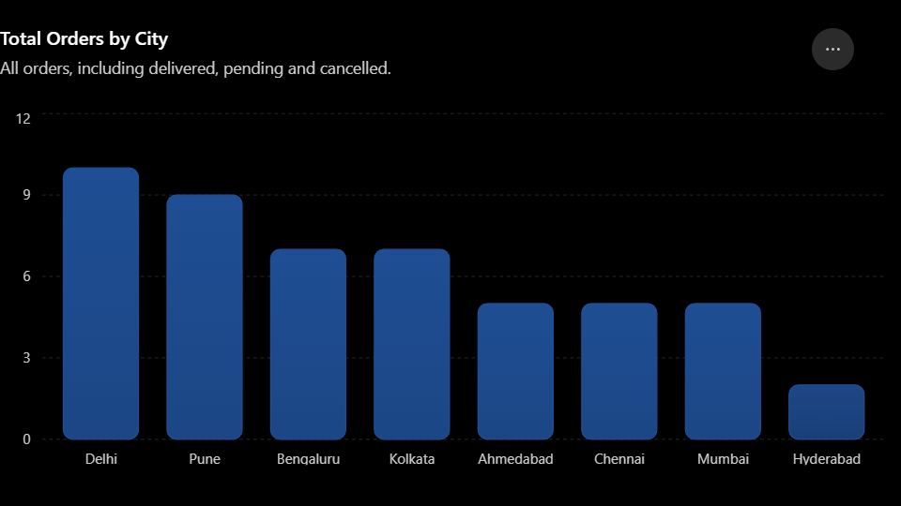
Key findings
- Delhi has the highest order volume, with 10 orders.
- Pune ranks second, with 9 orders.
- Bengaluru and Kolkata each record 7 orders.
- Hyderabad has the lowest order volume, with 2 orders.
➡️ Insight: Delhi and Pune have the highest recorded demand, but Pune's operational performance is weak. High order volume must be supported by reliable delivery capacity. Hyderabad may offer an opportunity for market development, but more data is needed to confirm its potential.

2. City-wise revenue performance
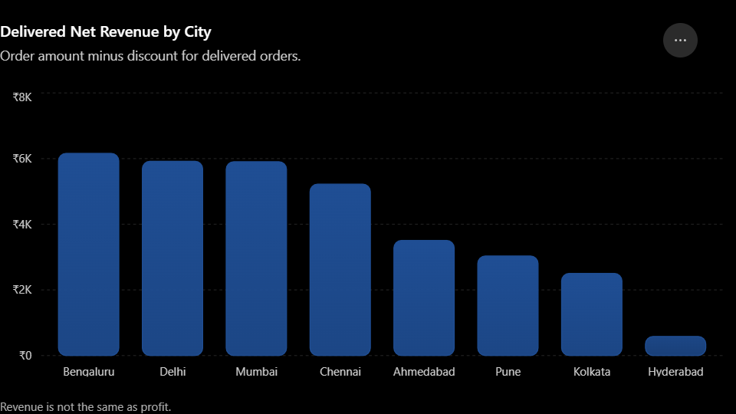
Rank | City | Delivered net revenue
1 | Bengaluru | ₹6,160.14
2 | Delhi | ₹5,919.00
3 | Mumbai | ₹5,905.73
4 | Chennai | ₹5,223.67
5 | Ahmedabad | ₹3,507.69
6 | Pune | ₹3,033.71
7 | Kolkata | ₹2,503.22
8 | Hyderabad | ₹581.63

➡️ Insight: Bengaluru is the leading revenue market, while Delhi combines the highest order volume with the second-highest revenue. The top four cities contribute approximately 70.68% of delivered net revenue. QuickBite should prioritize customer retention and consistent service in these markets.
3. Average order value by city

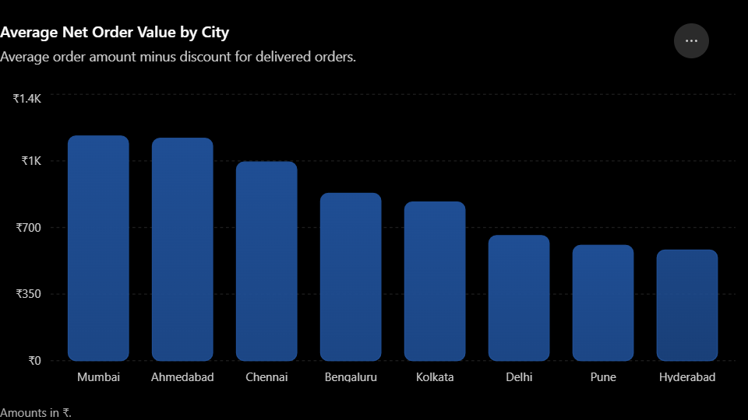

Key findings
- Mumbai has the highest average net order value at ₹1,181.15.
- Ahmedabad follows closely at ₹1,169.23.
- Hyderabad has the lowest average at ₹581.63.
- Delhi has high order volume but a relatively low average order value of ₹657.67.
➡️ Insight: Mumbai and Ahmedabad generate higher-value orders on average. Delhi could explore meal bundles, relevant add-ons, and carefully targeted promotions to increase average order value without unnecessarily reducing margins.

4. Delivery efficiency and delays
Fastest City
Ahmedabad 34.67 mins
Orders over 45 minutes
57.89% 22 of 38 deliverires

Average Delivery Time
49.32 min

Severe Delays
12 over 60 mins

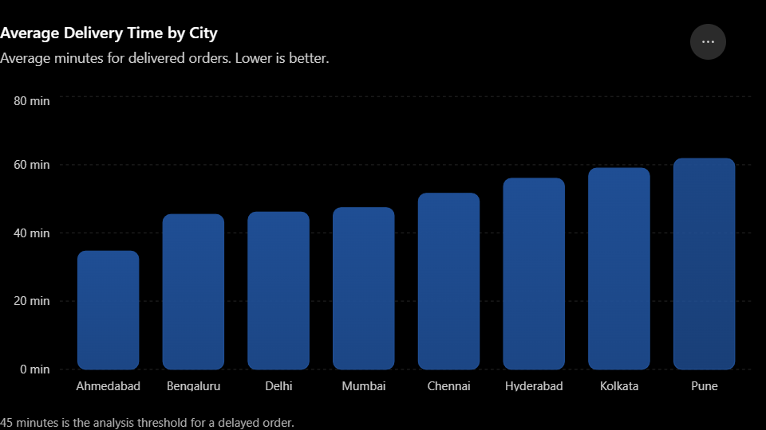
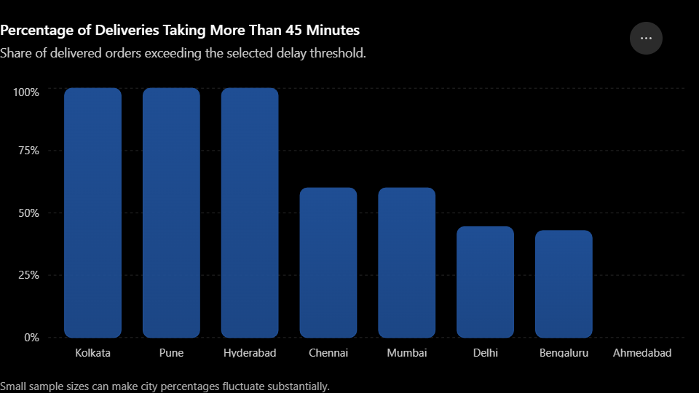
Key findings
- Pune has the slowest average delivery time at 61.80 minutes.
- Kolkata averages 59 minutes, followed by Hyderabad at 56 minutes.
- All recorded deliveries in Pune, Kolkata, and Hyderabad exceeded 45 minutes.
- Ahmedabad has the fastest average delivery time and no recorded deliveries exceeding 45 minutes.
- Chennai and Pune each have three severe delays exceeding 60 minutes.
➡️ Insight: Delivery efficiency is QuickBite's most visible operational concern. Pune should be the first priority for improvement, followed by Kolkata and Chennai. Management should investigate restaurant preparation time, delivery-partner availability, routing, and peak-hour demand. Hyderabad's result should be treated cautiously because it has only one delivered order.

- Cancellations and pending orders

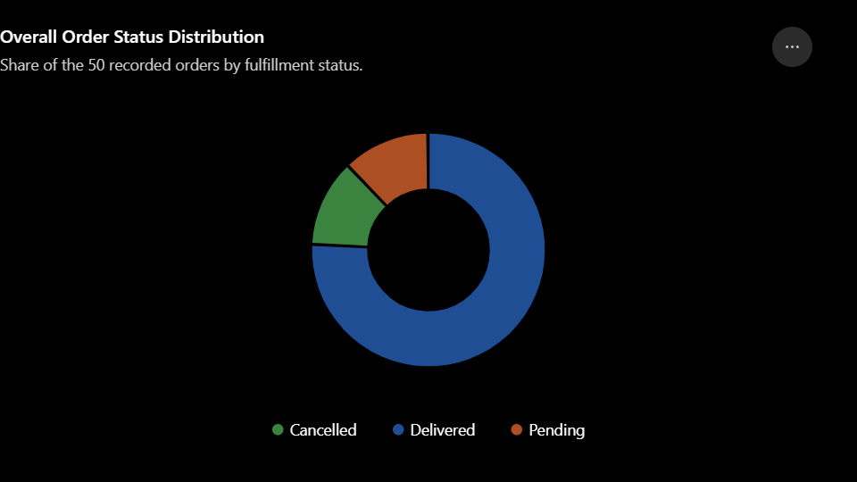
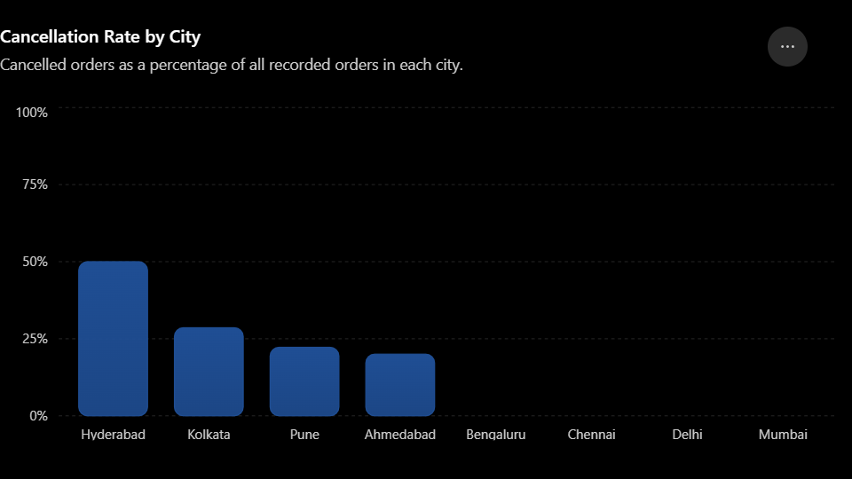

Key findings
- 38 orders (76%) were delivered.
- 6 orders (12%) were cancelled.
- 6 orders (12%) remain pending.
- Kolkata has the highest cancelled order value at ₹3,040.89.
- Kolkata and Pune have two pending orders each.
- Hyderabad has the highest observed cancellation rate at 50%, based on just two orders.

➡️ Insight: The combined cancellation and pending rate is 24%, which warrants investigation. Kolkata and Pune need attention because of their pending orders and other fulfillment issues. Hyderabad's cancellation rate is high, but the small sample is insufficient to conclude that it has a persistent cancellation problem.

7.City performance comparison
City | Revenue performance | Delivery performance | Priority
Bengaluru | Highest revenue | 45.43 min average | Maintain and optimize
Delhi | Highest order volume | 46.11 min average | Grow order value
Mumbai | High revenue and highest AOV | 47.40 min average | Retain and expand
Chennai | Fourth-highest revenue | 51.60 min; 3 severe delays | Improve fulfillment
Ahmedabad | Moderate revenue | Fastest at 34.67 min | Explore growth
Pune | Moderate-low revenue | Slowest at 61.80 min | High operational priority
Kolkata | Lower revenue | 59 min; cancellations and pending orders | High operational priority
Hyderabad | Lowest revenue | 56 min; small sample | Investigate and validate

➡️ Insight: Bengaluru, Delhi, and Mumbai are the strongest markets to protect. Pune and Kolkata are the clearest operational improvement priorities, while Chennai needs attention for severe delays. Ahmedabad's delivery performance makes it a candidate for carefully measured customer-acquisition efforts.

Strategic recommendations

- Market growth: Protect leading markets and evaluate targeted acquisition in lower-volume cities.
- Delivery operations: Prioritize Pune, Kolkata, and Chennai for delay investigation and fulfillment improvements.
- Cancellation management: Identify cancellation reasons and track pending orders until they reach a final status.
- Revenue optimization: Improve average order value in Delhi through relevant bundles and targeted offers.
- Performance monitoring: Track delivery time, cancellation rate, pending orders, and delivered revenue by city over time.
- Profitability measurement: Add delivery costs, restaurant payouts, commissions, and promotional expenses before comparing actual city profit margins.

Final conclusion
QuickBite's geographic analysis shows that Bengaluru leads in delivered net revenue, Delhi leads in order volume, and Mumbai has the highest average order value. Ahmedabad delivers fastest, while Pune has the slowest average delivery time. Kolkata and Chennai also show operational concerns, and cancellations and pending orders account for 24% of recorded orders.
The recommended approach is to strengthen leading markets, improve delivery efficiency in bottlenecked cities, and investigate growth opportunities in lower-volume markets. Since the dataset is small and does not include operating costs or historical trends, the findings should be used as initial business indicators rather than definitive measures of long-term growth or profit margins.

